2014 SOILS STUDY GUIDE

What is Soil?
Soil is a natural body comprised of solids (minerals and organic matter), liquid, and gases that occurs on the land surface, occupies space, and is characterized by one or both of the following: horizons, or layers, that are distinguishable from the initial material as a result of additions, losses, transfers, and transformations of energy and matter or the ability to support rooted plants in a natural environment.
The upper limit of soil is the boundary between soil and air, shallow water, live plants, or plant material that have not begun to decompose. Areas are not considered to have soil if the surface is permanently covered by water too deep for the growth of rooted plants.
The lower boundary that separates soil from the non-soil underneath is most difficult to define. Soil consists of horizons near the Earth’s surface that, in contrast to the underlying parent material, have been altered by the interactions of climate, relief, and living organisms over time. Commonly, soil grades at its lower boundary to hard rock or to earthy materials virtually devoid of animals, roots, or other marks of biological activity.

What is a State Soil?
A state soil is a soil that has special significance to a particular state. Each state in the United States has selected a state soil, twenty of which have been legislatively established. These “Official State Soils” share the same level of distinction as official state flowers and birds.
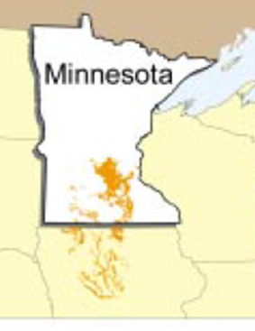

Lester—Minnesota State Soil
Lester soils are in 17 different counties in south-central Minnesota. They are of moderate extent and total over 600,000 acres. These soils formed under woody vegetation that has been removed in most areas for agricultural production. The principal crops are corn and soybeans. These soils are very productive and of significant importance to the economy in Minnesota.

What are soil horizons?
Soils form in bedrock residuum or in material deposited by ice, wind, water, or gravity. Layers, called horizons, form over time in the soils. These layers are evident where roads have been cut through hills or streams have scoured through valleys and in other areas where the soil is exposed. Where soil-forming factors are favorable, five or six master horizons may be in a mineral soil profile. Each master horizon is subdivided into specific layers that have unique identity. The thickness of each layer varies with location. Under disturbed conditions, such as intensive agriculture, or where erosion is severe, not all horizons will be present. Young soils have fewer master horizons.
The uppermost layer in an undisturbed soil may be an organic horizon, or O horizon. It consists of fresh and decaying plant residue from such sources as leaves, needles, twigs, moss, and other organic material. Some organic materials were deposited under water. The O horizon is dark because of large amounts of accumulated humus.
Below the O horizon is the A horizon. The A horizon is mainly mineral material. It is generally darker than the lower horizons because of varying amounts of humified organic matter. This horizon is where most root activity occurs and generally is the most productive layer of soil. It may be referred to as a surface layer in a soil survey.

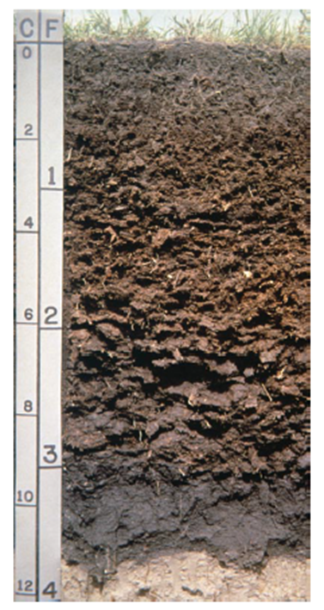
The E horizon generally is bleached or whitish. As water moves down through this horizon, soluble minerals and nutrients dissolve and some dissolved materials are washed (leached) out. The main feature of this horizon is the loss of silicate clay, iron, aluminum, humus, or some combination of these, leaving a concentration of silica sand and silt particles.
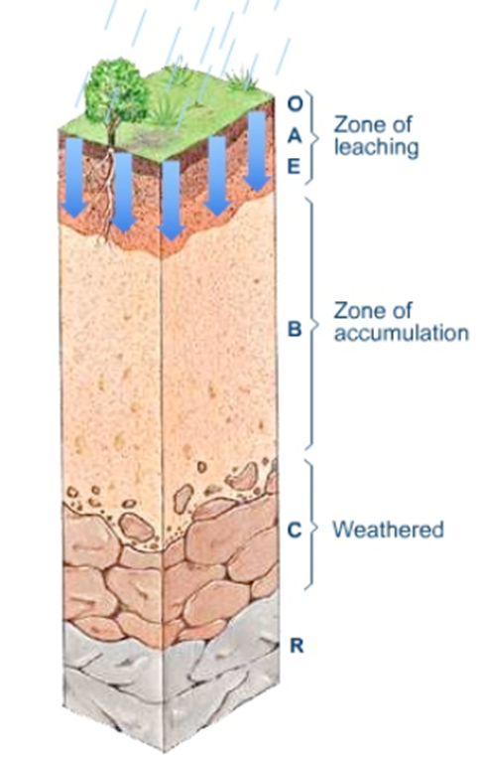

Below the A or E horizon is the B horizon, or subsoil. The B horizon generally is lighter colored, denser, and lower in content of organic matter than the A horizon. It commonly is the zone where leached materials accumulate. The B horizon is further characterized by the materials that make up the accumulation.
Still deeper in the profile is the C horizon, or substratum. The C horizon may consist of material with less clay than the overlying horizons, or it may consist of other less weathered sediments. Partially disintegrated parent material and mineral particles are in this horizon.
The lowest horizon, the R horizon, is bedrock. Bedrock can be within a few inches of the surface or many feet below the surface. Where bedrock is very deep and below the normal depths of observation, an R horizon is not described.

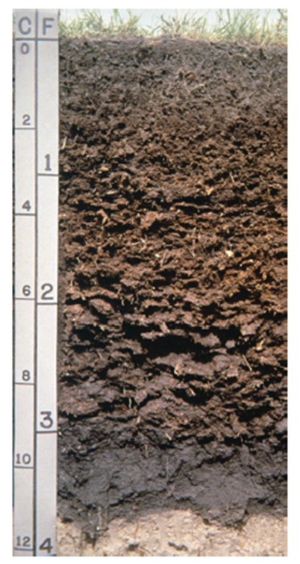

How is soil formed?
Soils form through the interactions of climate, living organisms, and landscape position as they influence the decomposition and transformation of parent material over time. Differences in climate, parent material, landscape position, and living organisms from one location to another and the amount of time the material has been in place all influence the soil-forming process.
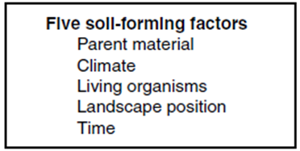

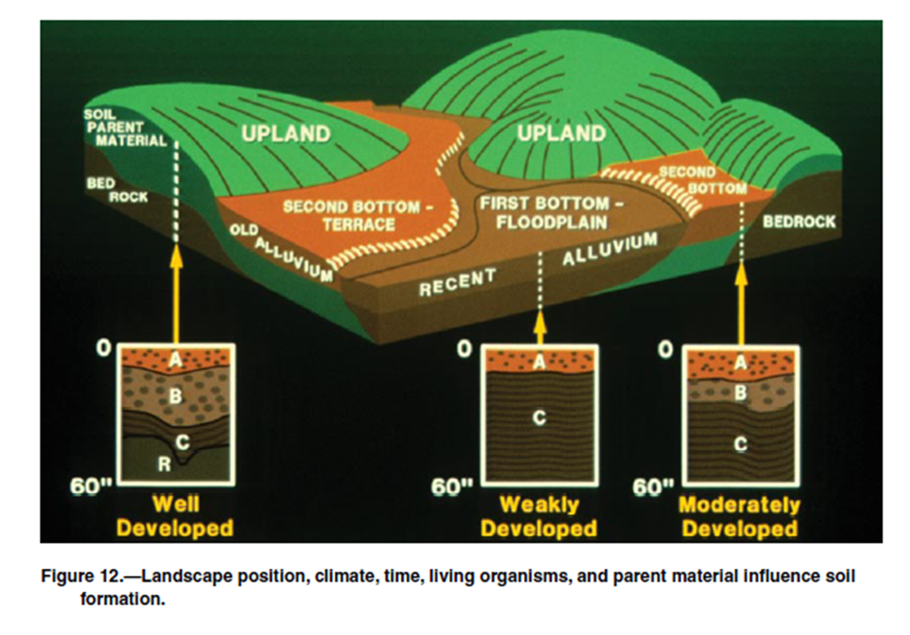

Parent Material
Parent material refers to the great variety of unconsolidated organic material (such as fresh peat) and mineral material in which soil formation begins. Mineral material includes partially weathered rock; ash from volcanoes; sediments moved and deposited by wind, water, or gravity; and ground-up rock deposited by glacial ice. The material has a strong effect on the type of soil that forms and the rate at which it forms. Soil formation may take place more quickly in materials that are more permeable to water. Dense, massive, clayey materials can be resistant to the processes of soil formation. In soils that formed in sandy material, the A horizon may be a little darker than its parent material, but the B horizon tends to have a similar color, texture, and chemical composition.

Climate
Climate is a major factor in determining the kind of plant and animal life on and in the soil. It determines the amount of water available for weathering minerals and for transporting the minerals and elements released.
Warm, moist climates encourage rapid plant growth and thus high organic-matter production. Also, they accelerate organic-matter decomposition. The opposite is true for cold, dry climates, under the control of climate, freezing, thawing, wetting, and drying break parent material apart. Rainfall causes leaching. Rain dissolves some minerals, such as carbonates, and transports them deeper into the soil. Some acid soils formed in parent material that originally contained limestone. Rainfall can also be acid, especially downwind from industrial processes.

Landscape Position
Landscape position causes local changes in landscape, water begins to move downward by the force of gravity, either through the soil or across the surface to a lower elevation. In an area where climate, living organisms, parent material, and time are held constant, the drier upslope soils may be quite different from the wetter soils at the base of the slope, where water accumulates. The wetter soils may have reducing conditions that will inhibit proper root growth for plants that require a balance of soil oxygen, water and nutrients.
The steepness, shape, and length of slopes are important because they influence the rate at which water flows into or off the soil. If unprotected, the more sloping soils may become eroded and thus have a thinner surface layer. Eroded soils tend to be less fertile and have less available water than uneroded soils of the same series.
Aspect affects soil temperature and moisture. In most of the continental United States, soils on north-facing slopes tend to be cooler and wetter than soils on south-facing slopes. These differences affect seedling emergence and the rate of plant growth. Soils on north-facing slopes tend to have thicker A and B horizons.

Living Organisms
Plants affect soil formation by supplying upper layers with organic matter, recycling nutrients from lower to upper layers, and helping to control erosion. In general, deep-rooted plants because the passages they create allow greater water movement, which in turn aids in leaching. Leaves, twigs, and bark from large plants fall onto the soil and are broken down by fungi, bacteria, insects, earthworms, and burrowing animals. These organisms eat and break down organic matter, releasing plant nutrients. Some change certain elements, such as sulfur and nitrogen, into usable forms for plants. Microscopic organisms and the humus they produce act as a kind of glue, holding soil particles together in aggregates. Well-aggregated soil provides the right combination of air and water to plant roots.

Time
Time is required for horizon formation. The longer a soil surface has been exposed to soil-forming agents, such as rain and growing plants, the greater the development of the soil profile. Soils in the areas of recent alluvial or windblown material and soils on steep slopes where erosion has been active may show very little evidence of horizon development. Soils on the older, stable surfaces generally have well defined horizons because the rate of soil formation has exceeded the rate of geologic erosion or deposition.
Slope
Slope is the gradient of an elevation change. A rise of 10 feet in a horizontal distance of 100 feet is a slope of 10 percent. Ranges of slope assigned to map units represent practical breaks on the landscape that are important for the use and management of the survey area. Terraces, irrigation, and tillage practices are all considered. For example, terraces can help to control erosion in some areas where slope is more than about 1 or 2 percent; thus, a separation of 0 to 2 percent and more than 2 percent for the same kind of soil may be used in mapping. Slope classes are not site specific, however, and for conservation planning, onsite investigation is necessary to determine the slope.
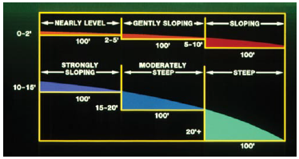

Slope Classes

Helpful Resources:
http://www.nrcs.usda.gov/wps/portal/nrcs/site/soils/home/
http://websoilsurvey.nrcs.usda.gov/app/HomePage.htm

Soil Texture
Texture is determined according to the relative proportions of sand, silt, and clay in the soil. Sandy soils tend to be characterized by low strength and a greater susceptibility to wind erosion and less water available to plants than soils of other textures. In addition, trenches and banks are highly susceptible to caving, which may pose a safety hazard.
Clayey soils generally have more available water than sandy soil. Silty soils have a higher available water capacity than sandy soils. In the absence of clay particles, silty soils have lower adhesive properties. In organic soils the term “muck” or “peat” is used in place of textural class names. Muck is well decomposed organic soil, and peat is raw, undecomposed material. The word “mucky” is used as an adjective to modify a texture class.
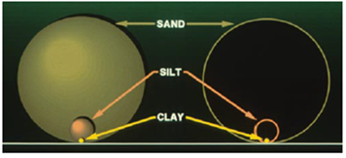

Relative sizes of sand, silt and clay

How to Use the Soil Texture Triangle
The USDA classifies soil types according to a soil texture triangle chart which gives names to various combinations of sand, silt and clay.
First, look at the orientation of the percentages on the sides of the triangle. The numbers are arranged symmetrically around the perimeter. On the left the numbers correspond to the percentage of clay, and on the right the numbers correspond to the percentage of silt. At the bottom of the triangle chart are the percentages of sand.
To classify a soil sample, you find the intersection of the three lines that correspond to the three proportions. On the chart, all the percents will add up to 100%.
Example: Classify a sol sample that is 30% clay, 15% silt, and 55% sand.
First locate 30% on the clay axis, and draw a line horizontally from left to right. Next, locate 15% on the silt axis, and draw a line going down diagonally to the left. Finally, locate 55% on the sand axis, and draw a line going up diagonally to the left. The intersection is in a region called Sandy Clay Loam. See figure below.
